APPLIED STATISTICS LAB

Name: SRIJITH U

Reg No.: 22BCE8916

Binomial Distribution

1.

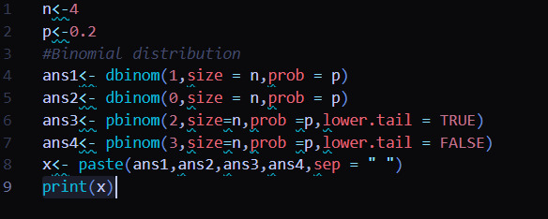

Output:



2. 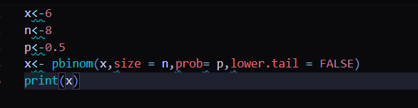

Output:



Poisson Distribution

1.

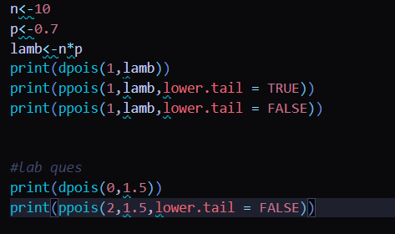

Output:

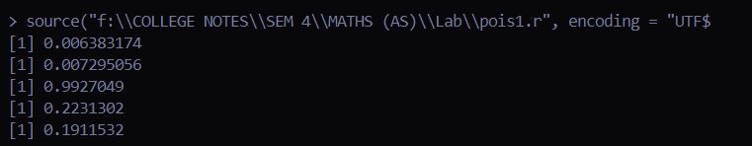

2.

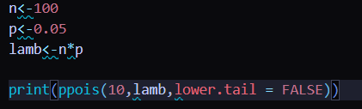

Output:

